TASK 1 :
1 No Display / Boot Failure
- Symptom: Display monitor remains black or enters standby ("No Signal"), and motherboard produces 1 long beep followed by 2 or 3 short beeps (indicating a RAM or GPU initialization fault).
2 Thermal Throttling / Overheating Shutdowns
- Symptom: PC powers on normally, but system fans instantly ramp up to maximum speed ($100\%$), followed by unexpected thermal cut-off/shutdown within minutes of launching demanding software.
3 Failing Storage Drive (HDD/SSD)
- Symptom: Windows freezes randomly, file transfers hang indefinitely, or the BIOS displays a "Boot Device Not Found" error accompanied by rhythmic clicking noises (if using a mechanical HDD).
4 Faulty / Unstable Power Supply Unit (PSU)
- Symptom: The computer instantly turns off or restarts without a Blue Screen of Death (BSOD) as soon as the graphics card or CPU enters a high-load state.
5 Corrupted RAM Stick / Memory Fault
- Symptom: Frequent, unpredictable Blue Screen of Death errors (MEMORY_MANAGEMENT or PAGE_FAULT_IN_NONPAGED_AREA) during routine desktop usage.

TASK 2 :

1. Check Wall Outlet and AC Cable:Isolate external power source issues.
- Action: Plug another device (e.g., a lamp or phone charger) into the wall outlet to ensure AC power is active.
- Check: Inspect the laptop power cord for physical fraying, bent prongs, or loose connections between the wall plug and the transformer brick.
2. Inspect Charger LED and Charging Port:Inspect adapter output and DC jack.
- Action: Plug the AC adapter into the laptop and check for a status light on the power brick or near the laptop's charging port.
- Check: Look inside the laptop's DC jack for debris, bent pins, or loose movement. Wiggle the connector gently—if the charging light flickers, the internal DC jack solder joint is broken.
3. Discharge Static / Embedded Power:Perform a hard power reset.
- Action: Unplug the AC adapter and remove the battery (if removable). Hold down the laptop power button for 30 seconds to clear residual motherboard capacitance.
- Check: Reconnect only the AC adapter (without battery installed) and attempt to turn the device on. If it powers on, the battery or battery controller is faulty rather than the adapter.
4. Inspect Battery Contacts and Physical State:Verify battery physical condition.
- Action: Remove the back cover (if battery is internal) and inspect the lithium cell.
- Check: Look for physical battery swelling/bloating, corroded ribbon cable terminals, or burnt smells near the charge controller IC.

TASK 3 :
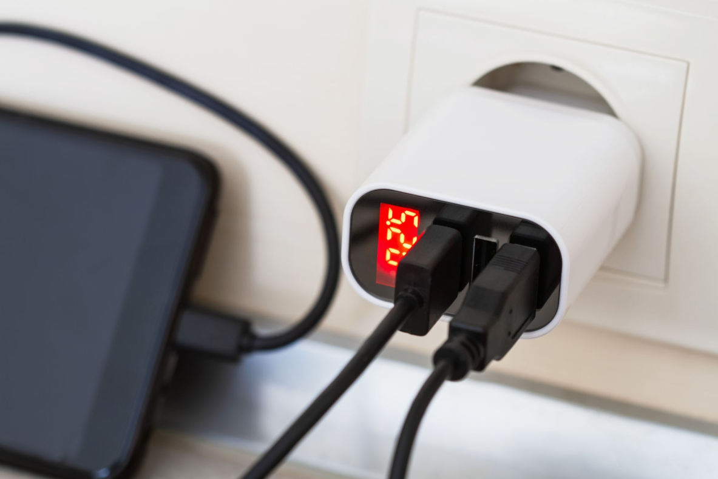
. Multimeter Test: Standard USB Charger Output
- Measurement Setup: A USB breakout board was connected to a standard 5V USB Type-A charger port. The multimeter was set to DC Voltage ($\text{V}\overline{..}$).
- Measured Voltage: $5.12\text{V DC}$ (probed between Pin 1 $V_{BUS}$ and Pin 4 $GND$).
- Evaluation: Within Expected Range. The reading falls squarely within the standard USB specification range of $4.75\text{V}$ to $5.25\text{V}$.

TASK 4 :
4. ATX PSU 12V Rail Testing Procedure
To test a disconnected ATX power supply, you must manually bridge the power-on pin using the "paperclip trick" before taking voltage measurements:
Step-by-Step Testing Steps
- Power Off & Disconnect: Turn off the PSU rocker switch and disconnect the 24-pin main motherboard connector from the motherboard.
- Enable PSU Jump: Insert a paperclip or jumper wire between Pin 16 (Green wire / PS_ON) and any Black wire (COM / Ground) on the 24-pin harness.
- Turn PSU On: Plug the power supply into the wall and flip its switch to ON. The PSU fan should begin spinning.
- Multimeter Probe Setup: Set the multimeter dial to DC Volts ($\text{V}\overline{..}$) on the $20\text{V}$ range.
- Take Measurement: Insert the Black probe into any black terminal pin (Ground) and the Red probe into any Yellow wire terminal pin (+12V) on the ATX connector or a peripheral Molex plug.
Test Results & Diagnosis
- Measured Voltage Reading: $11.35\text{V DC}$
What This Indicates
A $12\text{V}$ rail reading below $11.40\text{V}$ (more than a $-5\%$ drop below nominal rating) indicates degraded or failing Power Supply Unit (PSU) internal components (such as dried-out/bulging output capacitors or a failing transformer/voltage regulator). Under load, this low voltage causes voltage droop, resulting in random computer shutdowns, GPU instability, or hard drive head crashes.
